Normality Tests

Anderson–Darling: may be used with small sample sizes n ≤ 25. Very large sample sizes may reject the assumption of normality with only slight imperfections.

Jarque-Bera: is a goodness-of-fit measure of departure from normality, based on the sample kurtosis and skewness. The statistic JB has an asymptotic chi-square distribution with two degrees of freedom and can be used to test the null hypothesis that the data are from a normal distribution. The null hypothesis is a joint hypothesis of the skewness being zero and the excess kurtosis being 0, since samples from a normal distribution have an expected skewness of 0 and an expected excess kurtosis of 0 (which is the same as a kurtosis of 3).

Kolmogorov–Smirnov: is a form of minimum distance estimation used as a nonparametric test of equality of one-dimensional probability distributions used to compare a sample with a reference probability distribution (one-sample K–S test), or to compare two samples (two-sample K–S test).

Shapiro–Wilk test: tests the null hypothesis that a sample x₁, ..., x_{n} came from a normally distributed population.

Lilliefors test: adaptation of the Kolmogorov–Smirnov test used to test the null hypothesis that data come from a normally distributed population, when the null hypothesis does not specify which normal distribution, i.e. does not specify the expected value and variance.

Source: Wikipedia

Choices for Normality Testing
1) Kolmogorov–Smirnov compares the sample CDF to the normal CDF with mean equal to the sample mean and variance equal to sample variance. This methodology is very similar to the Anderson-Darling and Cramer-von Mises normality tests.

K-S test has several important limitations:
- It only applies to continuous distributions.
- It tends to be more sensitive near the center of the distribution than at the tails.
- Perhaps the most serious limitation is that the distribution must be fully specified. That is, if location, scale, and shape parameters are estimated from the data, the critical region of the K-S test is no longer valid. It typically must be determined by simulation.
Source: http://www.itl.nist.gov/div898/handbook/eda/section3/eda35g.htm

2) Shaprio Wilks uses the normal probability plot to test normality, specifically by testing the correlation between the theoretical quantile and the sample quantile.

For K-S, Using “Greater Than” Alternative Hypothesis
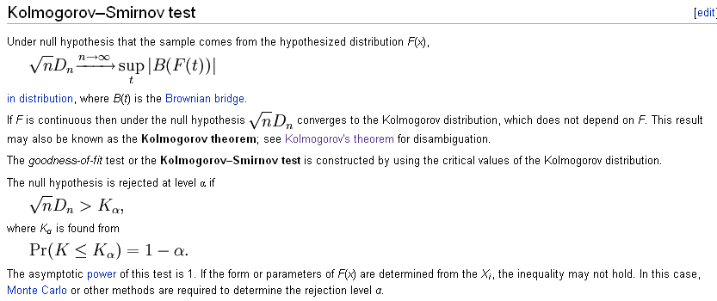

Simulation Results
{See Excel File}

